Response to change

Template

Please complete this section of the template before doing the research.

Step 1:

Think of two change experiences you have recently experienced and on the template provided, provide an overview of what the change was.

1. A change imposed upon you – where you felt like you didn’t have a choice in the change. It can a be a small or large change; gradual or sudden; expected or unexpected.
2. An intentional change where it was a conscious decision by you to initiate or support a change.

|  |
| --- |
| Change that was imposed on me:  During my 2nd year of Engineering I was very much connected with my Math class teacher.  She was very caring and her lectures were very much engaging.  But one day she left the college before the end of the semester.  Then new teacher was called for that subject and I was not felling connected with her.  This change made me losing my interest in her lectures and math subject.  This change made me angry and frustrated. |
| Change that was intentionally generated by me: |

Step 2:

Think about and record the range of reactions you experienced (mindset/emotions and behavior) as you went through the changes – from the beginning to the end.

|  |
| --- |
| The change that was imposed on me by our college department was something with which I have  accept it. Changes in life make you that your’re live not dead. Any how I had deal with it.I started spending more time listening that new teacher, given more time on that subject, asking  more doubts in lectures and eventually I again started getting interest in it like past. |
| The range of reactions experienced for the changed that I intentionally generated was: |

Step 3:

Complete the reading and research in the additional resources to get a better understanding of ‘why’ you experienced what you did and then complete the next page.

Step 4:

Now that you’ve done your research about the Change Curve, please complete the final section. Here is a reminder of the Change Curve:

The Kübler-Ross change curve

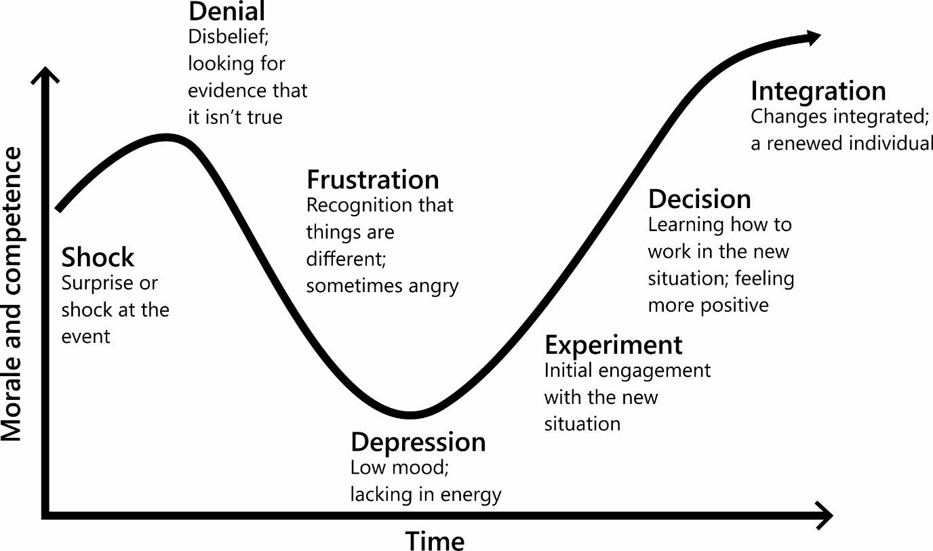

Step 5:

Identify what you have learnt from reflecting on this experience. Thinking back to the changes you wrote about earlier, identify what you have learnt from reflecting on this experience. It would also be beneficial to detail what happened at each stage of the Change Curve for you.

|  |
| --- |
| My reflections and learnings for the change that was imposed on me:  Changes are something which I always like to accept as changes make you feel that you are a living creature. It provides you with adaptability in life.  “Those can adapt the changes, will sustain, else will die”  Shock: I now understand that I was in shock when I was first told that my manager was not going to manage me anymore. I really didn’t expect it.  Denial: I definitely had a moment of denial, as I was so upset about losing my manager that I just didn’t want to accept that it was happening.  Frustration: I got very frustrated and I think I stayed at this stage for quite a while, as I just couldn’t see a way forward from this. It also made me angry with how I was being managed and I found this difficult to cope with – everything had changed, and I really didn’t like it. I felt like my career development was being negatively impacted by someone else.  Depression: I definitely recognize that my motivation dropped, and I didn’t have the same energy as I used to. In reflection, this may have been part of the problem, as perhaps this meant that I wasn’t performing as well as I used to, so the new manager didn’t know my capabilities. I also think I possibly didn’t make it easy for this new manager as I was continuously comparing them to my old manager. I didn’t really give them a proper chance to begin with or see how this change was also difficult for them. I didn’t start the relationship with an open mind as I just wanted them to replace  my old manager and keep everything the same.  Experiment: I asked for a meeting with my new manager to talk about how they were making me feel. I think this was me trying to engage with them and find a better way of working. I was close to  leaving the company but decided to try this approach first. It really was a bit of an experiment, but it paid off.  Decision: I think after the meeting we had a clearer understanding of how each of us liked to work, we could both move forward and progress with a new way of working. I think they respected me for wanting to try and improve the relationship.  Integration: The change is now integrated and working reasonably well. I didn’t leave the company (which was good because I didn’t really want too) and I ended up with a good relationship with my new manager – it was just different to my relationship with my previous manager. |
| My reflections and learnings for that change that I intentionally generated: |

Any final thoughts or reflections on how you could deal with change more effectively in the future?

**Changes are something which I always like to accept as changes make you feel that you are a living creature. It provides you with adaptability in life.**

**“Those can adapt the changes, will sustain or will die”**

**I always accept changes with courage and Interest.**